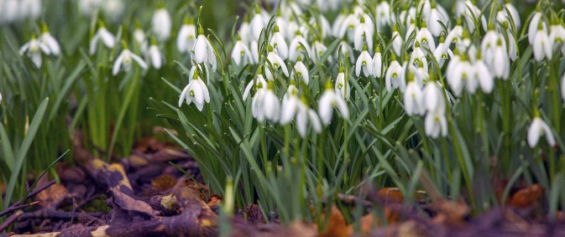
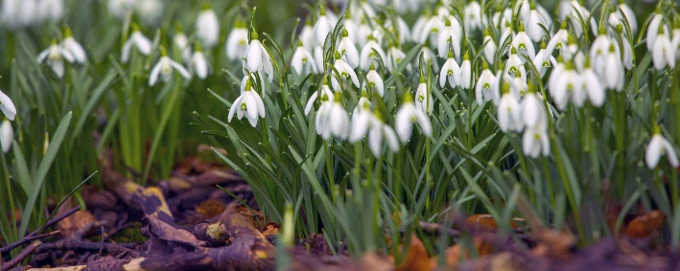
Friends of Wyke Regis and Lanehouse Practice (with Chickerell) News: February 2020

Tuesday Teas Together held every Tuesday afternoon
Please come along to the Wyke Regis Health Centre on a Tuesday between 2 - 4 pm to chat with the Friends whilst enjoying tea, coffee and cake. If you would like to come to the surgery but don’t have transport, please contact the surgery to see if transport might be available. The Friends are grateful to Wyke Regis Tesco for supporting this event.

Community Allotment
Sue, Rosemary, Teresa and Pennie are planning to visit the allotment (Allotment 21A, Rylands Lane) in the next few weeks (weather permitting) to begin to plan the initial work needed to prepare the ground for planting. Rosemary has taken cuttings of fruit trees for planting this year and has sourced a regular supply of manure! If you would like to help with growing flowers, fruit and vegetables please contact the surgery and provide your name and contact details and one of the Friends will be in touch once the weather improves.

Communication
The Friends regularly post information on the practice website and have recently redesigned the Friends section of this website to highlight the activities and work of the Friends. There are posters in all three surgeries advertising the activities of the Friends and the Patient Services Directory is available in hard copy in each surgery and on the practice website. You can also contact the Friends by email: wykefriends@gmail.com or by speaking to reception staff.

Would you like help to access on-line GP Services?
The Friends recently met with the local Digital Champions to discuss what support patients of the practice might need to register for on-line services and begin to use the computer system for ordering prescriptions and using the e-consult service. If you are interested in being taught how to register and use GP on-line services please contact the surgery and provide your contact details for further information.

February 1st 2020

